HT600-handheld pda scanner
HT600 is a high-performance intelligent data acquisition terminal independently developed by Lianqiang Youchuang. Android 13 operating system, equipped with a high-performance 8-core 2.2GHz clock speed processor, 6-inch high-definition large screen, and 16 million camera; Standard memory 4G+64G, optional 6G+128G, barcode scanning (optional scanning head model) NFC。 IP68 protection level, strong industry adaptability, widely used in various application fields such as logistics, retail, warehousing, medical, power, one card, parking fees, government projects, etc., helping users quickly achieve information management and improve enterprise operation efficiency.
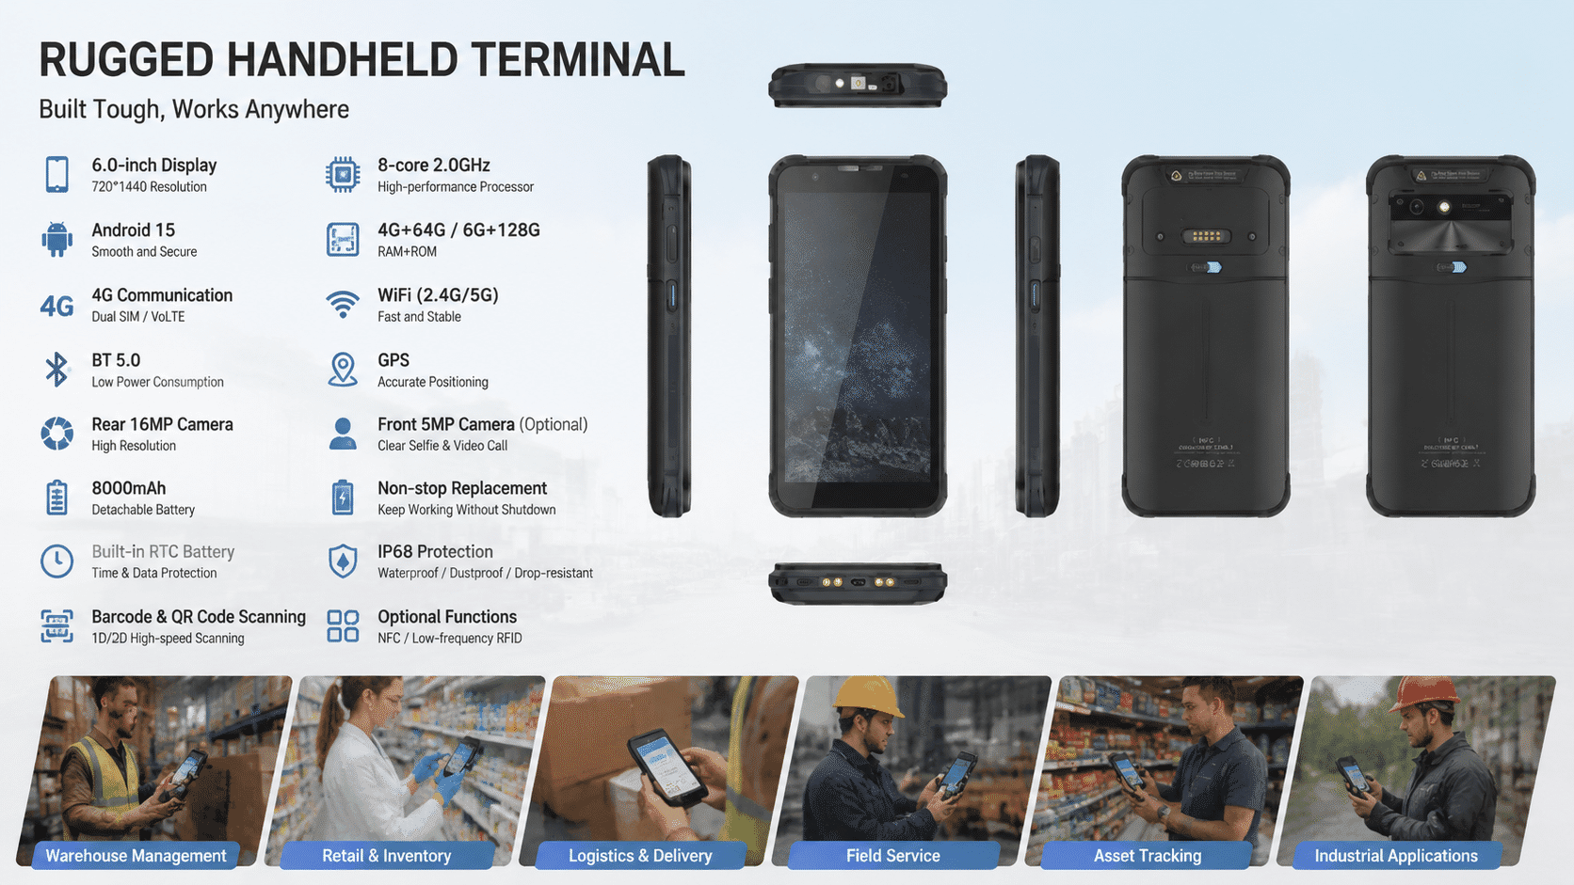

Basic Information
processor | 8-core 2.2GHz high-performance processor
operating system | Android 13
Memory(RAM+ROM) | 4GB+64GB (optional 6G+128GB)
expand memory | Micro SD card, supports up to 256GB
display screen | 6-inch IPS display screen resolution 720 * 1440, optional 2160X1080P
touch screen | Multi touch, can be operated with water on the screen or wearing gloves
rear camera | 1600W pixel high-definition camera, supporting autofocus and flash
front camera | 500W pixel camera (optional)
audio | Speaker (mono), microphone x 2, earpiece
prompt | Vibration prompt/LED prompt/audio prompt
keyboard | Silicone buttons: power button, volume+/- button, scan button x 2
booth | Nano SIM card x1/PSM card x1 (TF card)
battery | Rechargeable polymer battery (standard 3.8V 8000mAh) (low temperature -30 ℃ 7600mAh) (low temperature -40 ℃ 7000 mAh)  Standby time>350 hours  Working hours>12 hours (depending on the usage environment)  Supports fast charging, detachable battery, and supports replacing RTC battery without shutting down  Charging time<3 hours (using standard fast charging power adapter and data cable)
sensor | Light proximity sensor, distance sensor, gravity sensor  Optional: gyroscope, electronic compass
Communication transmission
USB port | Type-C USB x 1, Support OTG function
WLAN function | Dual band 2.4GHZ/5Ghz, supporting IEEE 802 a/b/g/n/ac protocols
Bluetooth | Supports BT 5.0, with a transmission distance of 5-10 meters
GPS | Supports GPS, Galileo, Glonass, Beidou
Wireless Wide Area Network | 2G: GSM (Mobile/Unicom), CDMA (Telecom)  3G: WCDMA (China Unicom), CDMA 2000 (China Telecom), TD-SCDMA (China Mobile)  4G: TD-LTE (Mobile), FDD-LTE (China Unicom, China Telecom)
Optional configuration
2D scanning engine | Soft solution: MD5066/Honeywell N5703/CM60  Hard solution: N660
Support 2D barcode type | PDF417,Micro PDF417,GS1 Composite,Aztec Code,Data Matrix,QR Code,Micro QR Code,  MaxiCode,Hanxin Code,etc.
Optional configuration
NFC | Working frequency: 13.56MHz  Protocol standards: Supports ISO14443A/B and 15693 protocols
Low frequency RFID (optional) | Support, 125K (distance 3-5cm)/134.2K (distance 10-17cm)
environmental parameters
Operating Temperature | -30 ℃ to 60 ℃  *For safety reasons, please do not charge in low temperature environments
Storage temperature | -40 ℃ to 70 ℃
humidity | 5% RH -95% RH (no condensation)
drop specification | Within the operating temperature range, all six sides can withstand a height of 1.8 meters  30 impacts of falling onto marble floors
Protection level | IP68
Development support
development language | Java
Develop API | Android Standard Interface
structural parameters
Size (mm) | 169.5mm×83.2mm×18.2mm
weight | <350g (Depending on the device's functional configuration)
Equipment accessories
standard configuration | Adapter, data cable, protective film, instruction manual, hand rope
optional | charging dock

